Day-01 Full Stack development Fundamentals

Task 1: Prepare an introduction to Full Stack Development

1. What is Full Stack Development?
Definition: Full Stack Development means developing both the frontend and backend of a web application and working with a database.
There are three main parts:
There are three main parts
1.Frontend
2.Backend
3.Database

Real-world example: Online shopping
Imagine you are using Amazon.
- Frontend: You see products, prices, and the Add to Cart button.
- Backend: When you click Add to Cart, the backend processes your request.
- Database: Stores product details, customer information, and order details.
All three parts work together to make the application function.

2. What is the difference between Frontend and Backend and Database?

1. Frontend
The frontend is the part of a website that users can see and interact with.
Technologies:
- HTML – creates the structure of a webpage.
- CSS – adds styling and design.
- JavaScript – adds functionality and interactivity.
- React – helps build user interfaces.
Example: On Amazon, the product images, search bar, buttons, and shopping cart are part of the frontend.

2. Backend
The backend is the part that works behind the scenes. It processes requests, applies business logic, and communicates with the database.
Technologies:
- Java
- Spring Boot
- Python
- Node.js
Example: When you place an order on Amazon, the backend processes the order and checks the required information.

3.Database
A database is used to store, organize, retrieve, update, and delete data in an application.

Real-world example
Imagine you are using Amazon. The database stores information such as:
- Customer details
- Product names and prices
- Order details
- Payment status
- Product stock

3.What is Client–Server Architecture?
1.Client–Server Architecture is a model in which a client sends a request to a server, and the server processes the request and sends back a response.

What are the main components?
- Client: The application or device that sends a request, such as a web browser.
- Server: Receives the request, processes it, and returns a response.
- Database: Stores and retrieves the required data.
- Network: Allows the client and server to communicate.

Real-world example
Imagine you open Amazon and search for a mobile phone.

4. What is the HTTP Request–Response Cycle?
The HTTP Request–Response Cycle is the process in which a client sends a request to a server, and the server sends back a response.
HTTP stands for Hypertext Transfer Protocol.

How does it work?
Step 1: Client
User clicks the “View Products” button.
Step 2: HTTP Request
The browser sends a request to the server.
Step 3: Server
The server processes the request and may access the database.
Step 4: HTTP Response
The server returns the requested data or an error message.
Step 5: Display Result
The browser displays the products to the user.

Common HTTP methods
- GET: Retrieve data.
- POST: Send data or create a resource.
- PUT: Replace or update a resource.
- PATCH: Partially update a resource.
- DELETE: Delete a resource.

Example
When you open a shopping website and view its products:
- The browser sends a GET request.
- The server retrieves the product information.
- The server sends a response.
- The browser displays the products.

5. What is a REST API?
1.REST API is a way for two software applications to communicate with each other using HTTP requests and responses.
2.A REST API allows two software applications to communicate with each other using HTTP requests and responses. It commonly uses methods such as GET, POST, PUT, and DELETE to retrieve, create, update, and delete resources. In Java, we can develop REST APIs using Spring Boot.
- REST: Representational State Transfer.
- API: Application Programming Interface.

6. What is a Java Full Stack Technology Stack?
A technology stack is a collection of technologies used to develop an application.
For Java Full Stack development, the common stack is:
Layer | Technologies
Frontend | HTML, CSS, JavaScript
Frontend framework | React
Backend | Java, Spring Boot
Database | MySQL
Database access | JDBC, JPA, Hibernate
Version control | Git, GitHub

7.Real-World Application Example
1.Online Shopping Application
2.Ecommerce Application
3.Online movie ticket booking
5.Online tour and travel management system
6.Online Banking Application etc
Task 2: Create a basic architecture diagram

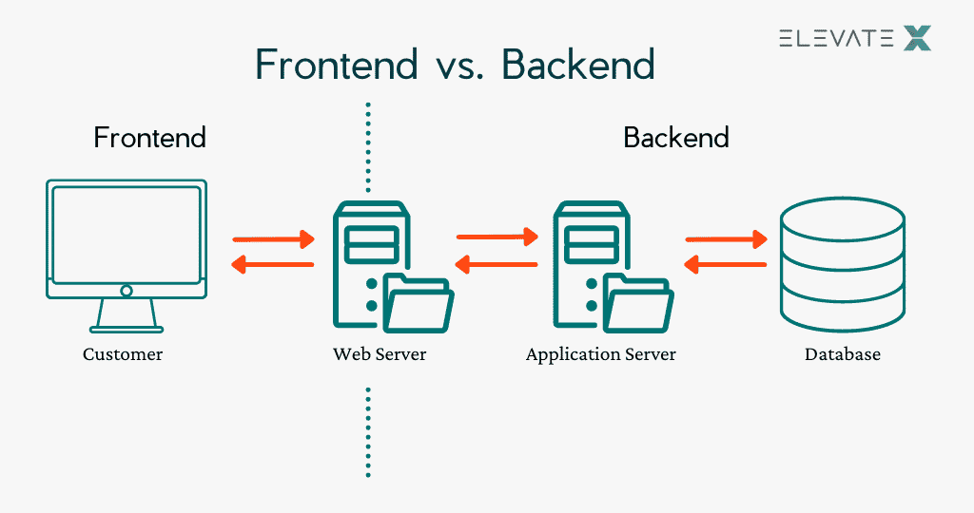

Task 3: Identify technologies used
• Frontend: HTML, CSS, JavaScript, React.js
• Backend: Java, Spring Boot
• Database: MySQL, SQL
• Communication: HTTP and REST APIs
• Development tools: Eclipse or IntelliJ IDEA, Git, GitHub

Overview of HTML, CSS, JavaScript, React.js, Java, Spring Boot, and SQL
This is the overview you can use for your Day 1 Full Stack Java Development Internship task. The explanations are in simple English.

1. HTML (HyperText Markup Language)
HTML is used to create the structure of a web page. It defines elements such as headings, paragraphs, images, links, buttons, and forms.
Example:
<!DOCTYPE html>
<html>
<head>
<title>My First Page</title>
</head>
<body>
<h1>Welcome to My Website</h1>
<p>This is my first web page.</p>
<button>Click Me</button>
</body>
</html>
Use: HTML provides the basic structure and content of a website.

2. CSS (Cascading Style Sheets)
CSS is used to style and design web pages. It controls colors, fonts, spacing, borders, and layouts.
Example:
h1 {
color: blue;
text-align: center;
}

p {
font-size: 18px;
}
Use: CSS makes web pages attractive and improves their layout.

3. JavaScript
JavaScript is a programming language used to make web pages interactive and dynamic.
Example:
function showMessage() {
alert("Welcome to my website!");
}
You can call this function when a user clicks a button.
Use: JavaScript handles actions such as button clicks, form validation, and dynamically updating page content.

4. React.js
React.js is a JavaScript library used to build interactive user interfaces. It allows developers to create reusable components.
Example:
function Welcome() {
return <h1>Welcome to React!</h1>;
}

export default Welcome;
Use: React.js helps developers build modern web applications using reusable UI components.

5. Java
Java is a high-level, object-oriented programming language. It is widely used for backend development, enterprise applications, and web applications.
Example:
public class Main {
public static void main(String[] args) {
System.out.println("Hello, Java!");
}
}
Use: Java implements application logic, processes data, and supports backend development.

6. Spring Boot
Spring Boot is a Java framework that simplifies the development of standalone and production-ready Java applications. It provides features such as auto-configuration and embedded servers.
Example:
import org.springframework.web.bind.annotation.GetMapping;
import org.springframework.web.bind.annotation.RestController;

@RestController
public class HelloController {

@GetMapping("/hello")
public String hello() {
return "Hello from Spring Boot!";
}
}
When the application runs, visiting /hello returns the message.
Use: Spring Boot helps developers create backend applications and REST APIs with less configuration.

7. SQL (Structured Query Language)
SQL is a language used to create, retrieve, update, and delete data in relational databases such as MySQL.
Example:
CREATE TABLE Student (
id INT PRIMARY KEY,
name VARCHAR(50)
);

INSERT INTO Student VALUES (1, 'Shivani');

SELECT * FROM Student;
Use: SQL allows applications to store, manage, and retrieve information from databases.

How these technologies work together

Frontend
HTML + CSS + JavaScript + React.js
Displays the user interface

Backend
Java + Spring Boot
Processes requests and business logic

Database
MySQL + SQL
Stores and retrieves data
For example, in a student management application:
- HTML and CSS create the student registration form.
- JavaScript and React.js make the form interactive.
- Java and Spring Boot process the submitted student details.
- SQL is used to insert the details into a MySQL database.
- The backend returns a response, and the frontend displays the result.
Conclusion: These technologies work together to build a complete web application. HTML, CSS, JavaScript, and React.js are used mainly for the frontend; Java and Spring Boot are used for the backend; and SQL is used to manage database information

